Lab Exercise 20 - STS (Security Token Service) in MinIO

1. Objective
This lab demonstrates how to use Security Token Service (STS) in MinIO to generate temporary, time-bound credentials for secure access. Learners will understand how STS improves security by avoiding long-term access keys and how it is used in real-world scenarios such as applications, CI/CD pipelines, and temporary users.

2. Lab Environment
Prerequisites
- MinIO server running (single-node or distributed)
- mc client installed
- Admin access to MinIO
- System time synchronized (chrony / ntpd)
Assumptions
- Alias name: myminio
- Bucket name: sts-bucket
- MinIO version: Latest stable

3. Concept Overview
STS in MinIO issues temporary credentials consisting of:
- Access Key
- Secret Key
- Session Token
These credentials:
- Expire automatically
- Are mapped to IAM policies
- Reduce the risk of credential leakage

4. Step 1: Configure mc Alias
mc alias set myminio http://localhost:9000 minioadmin minioadmin123

Verify:
mc admin info myminio

5. Step 2: Create a Bucket
mc mb myminio/sts-bucket

Step 1: Verify MinIO Admin Alias
Ensure that the MinIO admin alias exists.
mc alias ls

Expected:
myminio http://13.233.216.180:9000

Step 2: Create a Policy for Temporary Access
Create Policy File
vi sts-rw.json

Policy Content (sts-rw.json)
{
"Version": "2012-10-17",
"Statement": [
{
"Effect": "Allow",
"Action": [
"s3:GetObject",
"s3:PutObject",
"s3:ListBucket",
"s3:DeleteObject"
],
"Resource": [
"arn:aws:s3:::sts-bucket",
"arn:aws:s3:::sts-bucket/*"
]
}
]
}

Save and exit.

Step 3: Ensure Target Bucket Exists
Create the bucket if it does not already exist.
mc mb myminio/sts-bucket

Step 4: Create Temporary Access Credentials
Generate time-limited credentials (1 hour) using the policy.
mc admin accesskey create myminio/ \
--policy ./sts-rw.json \
--expiry-duration 1h

Sample Output
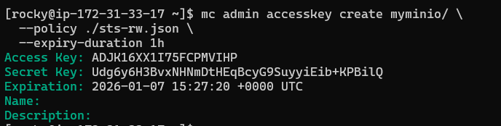
Step 5: Verify Temporary Access Key Details
mc admin accesskey info myminio/ Y184RSXX7QD70Y2VPH0B

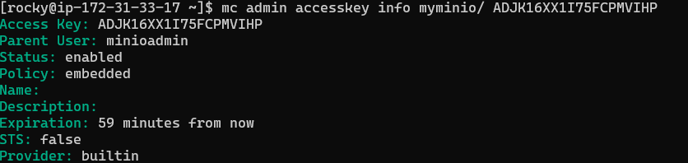
Step 6: Export Temporary Credentials
export MINIO_ACCESS_KEY=ADJK16XX1I75FCPMVIHP
export MINIO_SECRET_KEY=Udg6y6H3BvxNHNmDtHEqBcyG9SuyyiEib+KPBilQ

Step 7: Configure Temporary Alias
Create an alias using the temporary credentials.
mc alias set temp-user http://13.233.216.180:9000 $MINIO_ACCESS_KEY $MINIO_SECRET_KEY

Expected:
Added `temp-user` successfully.

Step 8: Verify Temporary Access Scope
List Buckets
mc ls temp-user
Expected:
- Buckets visible according to policy scope

Access Authorized Bucket
mc ls temp-user/sts-bucket
Access should be successful.

Upload a File
echo “hello sts” > test.txt

mc cp test.txt temp-user/sts-bucket

List Objects
mc ls temp-user/sts-bucket

Delete Object
mc rm temp-user/sts-bucket/test.txt

Step 9: Observe Credential Expiry
After 1 hour, run:
mc ls temp-user
Expected:
InvalidAccessKeyId / Access Denied
Explanation
Temporary credentials are automatically invalidated after expiry.

Step 10: Cleanup (Optional)
Remove temporary alias:
mc alias rm temp-user

Delete policy file:
rm sts-rw.json

